MMN Industries

Joshua Main-Smith

Kyle Montgomery

Kevin Nance

ABCD Newell Dr

Gainesville, FL 32611

# April 24, 2019

C&G Main Campus

123 Grinter Hall

PO Box 113001

Gainesville, FL 32611-3001

To the office of Contracts and Grants,

On April 8th, 2019 we received an RFP (Request for Proposal) from the University of Florida Office of Sponsored Research, funded by the U.S. Department of Commerce and U.S. Department of Energy. This aforementioned RFP purpose was to elevate the quality of life for U.F. students. Our proposal to this RFP is attached below.

We propose the installation of a pedestrian underpass at the intersection of Museum Road and Gale Lemerand Drive to help make walking on campus safer and easier. Research has demonstrated that convenient pedestrian structures implemented in pedestrian-heavy areas can expedite both foot traffic and vehicular traffic by shifting pedestrian traffic away from roads. Our team has analyzed pedestrian data including pedestrian accidents on campus and has finalized a construction plan we believe to be optimal for aiding U.F. campus pedestrians. We considered alternative pedestrian structures and believe an underpass with bollards to be the preferred action.

Our team is looking forward to this potential opportunity. We have combed through hefty amounts of data to bring forth what we truly believe to be the most optimal pedestrian-assisting proposal. We believe this underpass will aid foot traffic tremendously and with some artistic effort could become a sought after attraction on U.F. campus. We can be contacted at (352)246-7704.

Sincerely,

Joshua Main-Smith, Kyle Montgomery, Kevin Nance

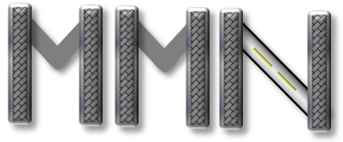

**Underpassing Traffic Barriers**

# **Joshua Main-Smith, Kyle Montgomery, Kevin Nance**

**April 24th, 2019**

**MMN Industries**

**ABCD Newell Dr**

**Gainesville, FL 32611**

# **Executive Summary:**

U.F. campus is a busy place with thousands of pedestrians every day, it is imperative that foot traffic on campus is streamlined and hazard-free for the benefit of all students and faculty. Students require satisfactory transportation options to travel from home or dorms to campus and from class to class quickly, safely, and efficiently. There is ample room for improvements in the quality of life for students and faculty navigating around campus on foot or bicycle.

Encouraging students and faculty to walk or bike, if feasible, is significant to combat the University of Florida’s growing issue of not enough parking spots. Making the campus friendlier to pedestrian traffic serves to promote a campus that is greener, healthier, and a more tightly knit community. The campus would benefit from more shelter from rain and the sun with the latter particularly important given Florida’s harsh summers. More work could be done to separate foot traffic from busy roads and intersections to keep the student body safer and reduce pedestrian accidents. Providing alternatives to waiting for crosswalks can also increase the speed in which pedestrians can arrive at their destination which can translate into less tardiness. All of these issues could be mitigated by a pedestrian underpass structure.

This proposal plans to install a pedestrian underpass on U.F. campus at the intersection of Museum Road and Gale Lemerand Drive diagonally from the northeast corner to the southwest corner. An underpass was chosen over alternative pedestrian structures such as an overpass primarily due to the decreased cost. There will be no issues with vehicular clearance unlike the other researched possibilities. It has also been shown that having a pedestrian structure open with an initial downward slope makes it far more appealing to bypassers.

Gainesville’s iconic Helyx footbridge has shown that when handled correctly pedestrian structures can benefit students and can become well-known landmarks. A pedestrian underpass near the bustling Reitz Union that houses important functions such as introducing new students would help exemplify U.F.’s dedication to improving the quality of life for their students. Opening the underpass up to student art could also serve to make the underpass a means of student expression similar to the beloved 34th street wall.

This structure will lower traffic congestion, decrease pedestrian travel times, and prevent accidents. The U.F. campus and brand will significantly benefit from its installation. This proposed project should directly benefit everyday American citizens at home, work, and school. We strongly urge the proposal committee to fund this much needed and beneficial project.

Table of Contents

**Letter of Transmittal** i

**Title Page** ii

**Executive Summary:** iii

**Problem Statement:** 1

**Background Research:** 2

Introduction 2

Methodology 3

Results and Discussion 4

Conclusion: 5

**Technical Plan:** 6

Preparation 6

Purchasing 7

Implementation 7

Advertising 8

**Budget and Schedule:** 8

Budget 8

Schedule 9

**Evaluation Plan:** 10

**References:** 12

Appendix: 14

Pictures 14

Table of Figure

Figure 1 7

Figure 2 8

Figure 3 9

Figure 4 11

Figure 5 18

Figure 6 18

# **Problem Statement:**

On April 12th, 2019 we received an RFP from the University of Florida’s Office of Sponsored Research. Funded by the US Departments of Commerce and Energy to promote new research in technology, it looks for proposals that will improve the standard of living for American citizens at home, work and school. Additionally, as we are students of the University of Florida and living in North Central Florida, we would love to increase the standard of living in Gainesville and promote the overall UF brand. This proposal to improve the transportation infrastructure via a pedestrian underpass at a busy and dangerous intersection will increase the quality of life for students, faculty, and Gainesville residents [6]. Decreasing traffic congestion, promoting green transportation, and preventing accidents will all help promote the UF brand.

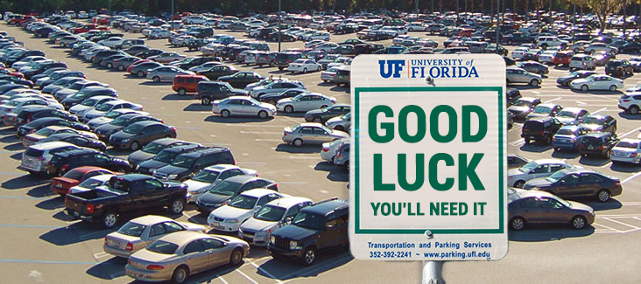

Students and faculty who live on campus or commute to it compete for limited parking availability and face serious traffic congestion. Traffic and parking have gotten so bad, internet memes like Figure 1 are now a top result on Google. The increased time wasted waiting in traffic and at intersection crossings or searching for a spaced in crowded parking lots cuts into productivity at work and school and reduces time spent with friends and family [13]. Walking and biking to campus would be a good option to help this problem if not for the dangerous and busy intersections that must be crossed [7]. Additional space for new parking infrastructure is limited and would only incentivize more people to drive, which may further contribute to the problem rather than fixing it [14]. The main campus walkways also lack protection from the elements, which can make walking or biking difficult in the intense Florida sun or frequent flash rainstorms. 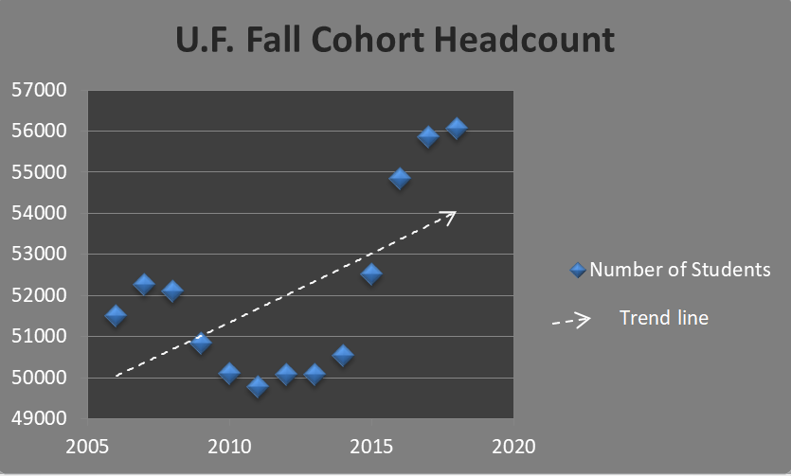

Additionally, the total number of students attending UF is on an upward trend as seen in Figure 2. This increase in student population will lead to additional transportation problems. UF must be forward looking and plan for the long term. The parking and congestion problem will only get worse in the future, unless a proactive plan to fix it is found and implemented.

Our research develops a solution to all of these problems by building a pedestrian underpass under a busy and important intersection on campus. We will investigate the ideal location for the underpass by showing the most dangerous and problematic intersections on campus, and we will show the numerous benefits to safety and traffic reduction from available academic research. We will present a strong and compelling argument that our proposal for the underpass will significantly increase the general quality of life for students, faculty, and Gainesville residents near the University of Florida campus.

# Background Research:

## Introduction

Commuting to and from campus has been an increasing problematic situation for students. The total number of traffic crashes from 2011 to 2013 has been steadily rising, with a lot of the roadways around campus also providing pedestrian access the campus and surrounding parks [7]. This will become a more prevalent issue as the student body for UF increases with each year, leading to less room on the buses, less parking space availability, longer traffic delays, and more students opting for biking or walking to class not only in Gainesville but in Miami as well [8]. The urgency to analyze bottlenecks in congested areas and potentially dangerous locations is growing in importance in ensuring pedestrian safety [1][5].

An underpass can further provide shelter from intense weather conditions, such as the rain and intense sunlight while also serving as an area where students from the art department can use the walls of the underpass as an outlet for creative expression [3]. Additionally, this will also be a growing issue for faculty as only 55% of the staff do not live within a direct transit ride to campus leading to only 5% using the transit for commuting (as opposed to the 90% of students that live within a direct transit line and 27% using the transit system). These issues will permeate into other aspects of UF logistics, such as providing a poor experience for potential employees and visitors (especially if they are unfamiliar with the campus), increased discomfort for those on the outskirts of campus using other modes of transportation (such as difficulty in cycling navigation and increased scooter collisions), etc [6].

Constructing an underpass in an area at or near a location reported to have a high pedestrian congestion rate and high traffic collisions would be ideal. This would provide a safer and more efficient system than the one that is currently present by redirecting crowd flow away from the dangerous traffic above which is especially important in the modern age where people are distracted by their mobile devices [4].

## Methodology

Upon searching for an idea location to construct an underpass, we have found that UF has created a map on their vision in creating a designated bicycle and pedestrian zone dated back to 2018, which can be seen in Figure 1 [6].

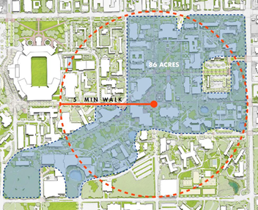

**Figure 1. UF Bicycle and Pedestrian Zone**

Further, we have found traffic collision statistics dating between 2006 to 2013 showing problematic points in transportation [7]. Below in Figure 2 we can see the five most common areas of pedestrian accidents based on the data around UF campus and surrounding Gainesville area [7]. The campus master plan also details the intersections within U.F. campus that have the highest foot traffic [7]. Foot traffic numbers in conjunction with pedestrian accident data assists in finding which areas within U.F. a pedestrian structure would not only be of the most use but secure the safety of the most students. The chosen intersection will also have to require enough clear space around the proximity to facilitate the construction which will need to be in a convenient location to assure that the majority of pedestrians do not simply ignore the underpass due to the length it takes to traverse [10].

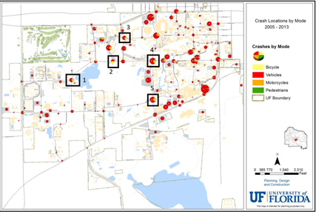

**Figure 2. Accident Locations on Campus**

## Results and Discussion

Based on the data and UF’s vision for a designated pedestrian walkway, we have decided that the best place to construct an underpass would be between Museum Road and Gale Lemerand. This intersection is about a five minute walk south from the beginning of the proposed designated walk zone located above in Figure 1 and has a high frequency of pedestrian accidents per year as shown in Figure 2. An underpass constructed here would alleviate traffic and pedestrian congestion and it would provide an efficient passage into the pedestrian walking and biking zone. Additionally, this intersection would be ideal when considering all transit routes that pass through here and the parking spots that are, or will be, nearby. The proposed transit route system from UF’s master plan [6] can be seen in Figure 3 below. While UF students are waiting for the bus, an underpass at this location would provide shelter from the rain. Also included in the master plan is an additional two parking lots added south of Museum Road and Gale Lemerand near SW Archer Road as well as an added scooter parking lot south of Museum Road across the street from the physics department. All of these additions can be seen in Figures 5 and 6 in the appendix. When considering the number of routes, parking lot additions, and high frequency of accidents that occur around the Gale Lemerand and Museum Road intersect, we believe that an added underpass would significantly alleviate the high crowd congestion leading to a lower frequency of pedestrian-vehicle accidents.

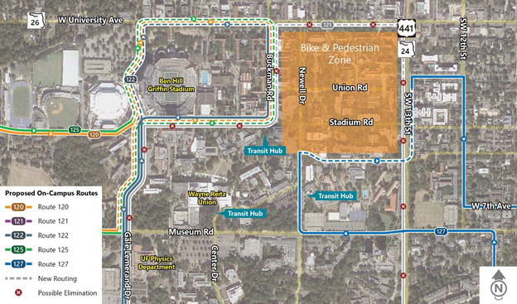

**Figure 3. Proposed On-Campus Transit Routes**

A survey conducted by the Florida Department of Transportation found that 93% of people believe that good pedestrian options add value to their community, and most agreed that they would walk more if better options existed [9]. The proximity of the proposed structure to the Reitz Union, one of the most iconic and trafficked U.F. buildings, would provide many positive benefits including higher pedestrian flow and less accidents, which will be detailed in the full proposal. While this is our educated opinion based on data and knowledge of the campus, there exists a method using MAC addresses to make heat maps to determine which areas are most problematic, which could be implemented on campus through student smartphone use to definitively decide on an ideal location [2]. This could be used to confirm our decision or give further guidance in the future. The specific details on the implementation and where the entry points to the structure will be located are still being researched and discussed at this point in time.

## Conclusion:

The results of our research paint a clear picture that supports our proposal for a pedestrian underpass to help alleviate traffic, reduce accidents, and increase the ability for students and faculty to walk to and from campus. We believe our research suggests an ideal location for the underpass between Museum Road and Gale Lemerand. The year over year increase in traffic accidents combined with its proximity to the campus show it will be a promising new addition to campus infrastructure. We stand behind our conclusions and hope the proposal committee will see all the potential benefits and approve funding for our project.

# **Technical Plan:**

To make walking to and from campus for UF students and faculty safer and more convenient, MMN Industries will help redirect pedestrian traffic by constructing an underpass in an area with high crowd congestion, heavy traffic, and frequent vehicle-pedestrian accidents. We believe that the location for the underpass that we are proposing is optimal when considering the various modes of transportation that occur in or around the Gale Lemerand and Museum Road intersection.

## Preparation

Before beginning excavation, we would need to survey the landscape and take soil samples of the surrounding area. If the physical characteristics of the soil appear to be loose then we would need to provide soil stabilization techniques, such as places a series of pipes underground and either injecting grout or some sort of refrigerant [cite].

Next, to avoid disrupting the existing road that we will be underpassing we will make use of the tunnel boring method. This technique makes it possible to excavate an underpass underneath an existing structure, like a road or railway, without disrupting traffic. This is accomplished by incrementally introducing an array of pipes underneath the structure, supporting it during the excavation. Below in Figure 3 is a drawing representing the technique [12].

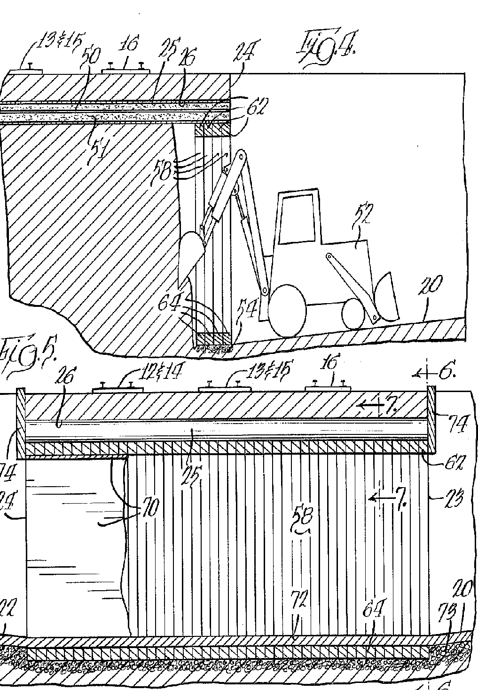

**Figure 4. Tunnel Boring Excavation Method**

## Purchasing

We will then need to purchase raw materials necessary during construction. If the soil tested appears to be unstable, we will need to purchase grout for stability and to fill in the empty spaces. If we would rather freeze the underground soil, instead we would need to purchase liquid nitrogen or water and salt brine. Further, we would need cement for the structure and steel for the lining of the tunnel.

Additionally, to protect the underpass from water damage we will need waterproofing material (such as mastic asphalt) and a drainage system. Channels can be constructed to direct water flow to a nearby water sewage system or into Hume Pond located nearby. Lastly, to increase the safety of pedestrians, we would add four bollards, which help to slow down the surrounding traffic, and railing for the stairways and along the length of the underpass.

## Implementation

The underpass will begin south of Museum Road and east of Gale Lemerand Drive. It will then be built north across Museum Road, exiting on the other side. The total length of the underpass will be approximately 100 feet long, 30 feet wide, and about 15 feet high from the floor to the ceiling. The underpass will also contain a bike ramp off to the side for those who decide to cycle to campus can use the underpass safely. There will also be an area where students can creatively express their thoughts and feelings by painting along the wall.

## Advertising

The new underpass could be advertised to let students know about it and plan their routes accordingly, especially if students were avoiding the intersection due to the heavy crowd congestion. The underpass could be advertised by sending emails with the construction updates, putting up fliers, devoting a webpage on UF’s website with information about the project, and creating a survey asking the students what their opinion is regarding the underpass and if they plan on changing their usual route to utilize it.

# **Budget and Schedule:**

## Budget

The total cost for an underpass can range from as low as $1.6 million to a little over $10 million. There are a number of comparable projects that have been completed recently from around the United States. A budget of $4.5 million was planned for a pedestrian underpass in Inlet Beach, Florida. $6.26 million was budgeted for an underpass project in Scottsdale, Arizona. The Basalt pedestrian underpass project in Colorado cost $6.2 million and was completed in 2017. Another underpass for pedestrians and cyclists in Boulder, Colorado has a budget of $4.4 million and construction is scheduled to begin this year. Table 1 below shows the varying cost of the different components that is necessary for the construction of an underpass. Typically, an underpass usually costs about $120 per square foot as of 2013 [11]. Adjusting this for inflation, that would be about $132 per square foot. Taking the dimensions discussed above (100 feet long, 30 feet wide, and 15 feet high) it would approximately cost $5.9 million for just the construction of the underpass.

The range of expense for lighting can be anywhere from $7.20 to $690 per foot. Having railing from one end of the underpass to the other would cost an additional $720 to $69,000. Underpass lighting tends to range from $350 to $3,400 each. If we provide a light on each side of the wall every five feet, the cost for this would range between $14,000 to $136,000. Street bollards are commonly used to slow traffic and to protect the surrounding pedestrians. Adding four bollards would cost between $248 and $16,520.

This brings the total cost between just under $6 million to a little over $6.1 million, which falls within the designated budget [11].

|  |  |  |  |  |  |  |
| --- | --- | --- | --- | --- | --- | --- |
| Infrastructure | Description | Median | Average | Minimum | Maximum | Cost Unit |
| Underpass | Pre-Fab Steel | $191,400 | $206,290 | $41,850 | $653,840 | Each |
| Railing | Pedestrian Rail | $95 | $100 | $7.20 | $690 | Linear Foot |
| Lighting | In-Pavement Lighting | $18,250 | $17,620 | $6,480 | $40,000 | Total |
| Bollard | Bollard | $650 | $730 | $62 | $4,130 | Each |

**Table 1. Cost of Components**

## Schedule

|  |  |  |  |  |  |  |  |  |
| --- | --- | --- | --- | --- | --- | --- | --- | --- |
| **Task** | **7/1/19** | **8/1/19** | **10/1/19** | **12/1/19** | **2/1/20** | **5/1/20** | **6/1/20** | **7/1/20** |
| **Survey Land** |  |  |  |  |  |  |  |  |
| **Clear necessary obstacles** |  |  |  |  |  |  |  |  |
| **Begin Excavation** |  |  |  |  |  |  |  |  |
| **Assess needed materials** |  |  |  |  |  |  |  |  |
| **Purchase raw materials** |  |  |  |  |  |  |  |  |
| **Construct underpass** |  |  |  |  |  |  |  |  |
| **Install railing, bollards, and other finishing touches** |  |  |  |  |  |  |  |  |

The schedule proposed in Table 4 illustrates the expectations of the construction project timeline. Two months should be enough time to evaluate the land, clear debris, and prepare for construction. We propose this could begin this July. Four months would be allocated for assessing and purchasing materials as well as the preliminary stages of excavation. Another four months will be set aside for constructing the underpass. Once construction is complete, we expect one more month for installing railing, bollards, lighting, and any other necessary cosmetic features. We believe the proposed timeline of one year is sufficient to complete the construction, but we do understand that construction often runs into delays and other problems. If the project is approved, our proposed construction management team would provide a very precise timeline estimate. The construction would certainly cause delays and transportation problems while underway, so we believe it is in the best interest of everyone to have it completed as quickly as safely possible.

# **Evaluation Plan:**

The underpass construction project team will supply monthly progress reports about the updated status of operations to the appropriate agency. These progress reports will detail the actions being performed at the time, exactly what follow-up steps will be taken next in the construction, whether the project is on time and within budget constraints, the current expense report spreadsheet, and whether any unforeseen obstacles have occurred. These construction progress reports will use layman’s terms and be straight to the point to be completely accessible to the funding agency. Each progress report will build on the previous expense report in a comprehensive expense breakdown. This will provide the funding agency complete transparency of the associated costs of the construction and allow them to verify that the team completes all work within the allocated budget and schedule.

When the project is finished, the integrity of the underpass will be tested. The underpass post-construction will be verified to be safe and ready for pedestrians through implementing non-destructive radiography testing. This will give insight into the strength of the material used and whether there are potentially dangerous cracks or weak spots within the material itself. Radiography testing in conjunction with manual driving heavy vehicles over the intersection prior to it opening to the public will guarantee the structural integrity of the pedestrian underpass. Ideally the underpass will also be observed during various weather conditions to affirm its robustness in less than ideal circumstances. If this is not possible then pumping the underpass with water will be done to make sure the water drainage system is fully operational to prevent any possibility of the structure flooding.

Considering the proposed team successfully built pedestrian walkways for the University of Florida in the past, we expect this project to also succeed and bring all the benefits discussed in this proposal to the UF Campus, its students and faculty, and Gainesville residents.

# **References:**

[1] L. Huang, S.C. Wong, M. Zhang, et al. “Revisiting Hughes’ dynamic continuum model for pedestrian flow and the development of an efficient solution algorithm,” *Tra. Res. Met.* vol. 43, no. 1, pp. 127-141, Jan. 2009.

<https://www.sciencedirect.com/science/article/pii/S0191261508000751>

[2] N. Abedi, A. Bhaskar, and E. Chung, “Tracking spatio-temporal movement of human in terms of space utilization using Media-Access-Control address data,” *App. Geo.* vol. 51, pp. 72-81, Jul. 2014.

<https://www.sciencedirect.com/science/article/abs/pii/S0143622814000629?via%3Dihub>

[3] P. R. Anciaes and P. Jones, “Estimating preferences for different types of pedestrian crossing facilities,” *Transportation Research Part F: Traffic Psychology and Behaviour*, vol. 52, pp. 222–237, 2018.

<https://www.sciencedirect.com/science/article/pii/S1369847816303369>

[4] K. W. Byington and D. C. Schwebel, “Effects of mobile Internet use on college student pedestrian injury risk,” *Accident Analysis & Prevention*, vol. 51, pp. 78–83, 2013.

<https://www.ncbi.nlm.nih.gov/pmc/articles/PMC3556232/>

[5] R. J. Schneider, A. J. Khattak, and C. V. Zegeer, “Method of Improving Pedestrian Safety Proactively with Geographic Information Systems: Example from a College Campus,” *Transportation Research Record: Journal of the Transportation Research Board*, vol. 1773, no. 1, pp. 97–107, 2001.

<https://journals.sagepub.com/doi/abs/10.3141/1773-12>

[6] University of Florida, “Transportation & Parking Strategic Plan,” *TAPS Study Results,* pp. 3-45, November 2018. <https://documentcloud.adobe.com/link/track?uri=urn%3Aaaid%3Ascds%3AUS%3A0e1e9c53-b10c-4be7-ad10-4b2227836702>

[7] University of Florida, “Transportation Data & Analysis,” *University of Florida Campus Master Plan, 2015-2025,* pp. 8-30, June 2015.

<http://www.facilities.ufl.edu/plan/docs/da/Transpo.pdf>

[8] C. Simek, P. Turner, and M. Greenman, “Bicycle and Pedestrian Travel: Exploration of Collision Exposure in Florida,” *Final Report*, pp. 1-41, Sep. 2002.

<https://fdotwww.blob.core.windows.net/sitefinity/docs/default-source/content/safety/4-reports/bike-ped/2002-exposure-survey-rev.pdf?sfvrsn=7cc33d2_0>

[9] C. Hagelin and J. Avery, “Statewide Survey on Bicycle and Pedestrian Facilities,” *Florida Department of Transportation Office,* pp. 1-71, May 2007.

<https://fdotwww.blob.core.windows.net/sitefinity/docs/default-source/safety/safety/4-reports/bike-ped/statewide-survey-on-bike-ped-facilities-final-report.pdf?sfvrsn=1b4a9db3_0>

[10] “Evaluation of Pedestrian-Related Roadway Measures: A Summary of Available Research,” *Federal Highway Administration*, pp. 37-40, April 2014. <http://www.pedbikeinfo.org/cms/downloads/PedestrianLitReview_April2014.pdf>

[11] M. Bushell, B. Poole, C. Zegeer, and D. Rodriguez, “Costs for Pedestrian and Bicyclist Infrastructure Improvements,” *Federal Highway Administration*, pp. 20-21, Oct. 2013.

<http://www.pedbikeinfo.org/cms/downloads/countermeasure%20costs_report_nov2013.pdf>

[12] D. Patzner, “Method for Constructing a Tunnel or Underpass,” 01-Mar-1977.

<https://patentimages.storage.googleapis.com/ab/9b/b4/34ba170df9ea82/US4009579.pdf>

[13] A. Hirschi, K. Shockley, and H. Zacher, “Achieving Work-Family Balance: An Action Regulation Model,” *Academy of Management Review*, vol. 44, no. 1, pp. 150-171, Jan. 2019.

<http://lp.hscl.ufl.edu/login?url=http://search.ebscohost.com/login.aspx?direct=true&AuthType=ip,uid&db=buh&AN=133577728&site=eds-live>

[14] M. Koryagin, “Urban Planning: a Game Theory Application for the Travel Demand Management,” *Periodica Polytechnica Transportation Engineering*, vol. 46, no. 4, pp. 171-178, Aug. 2016.

<http://lp.hscl.ufl.edu/login?url=http://search.ebscohost.com/login.aspx?direct=true&AuthType=ip,uid&db=aci&AN=131724789&site=eds-live>

[15] University of Florida, “Enrollment & Demographics,” U.F. Institutional Planning and Research

<https://ir.aa.ufl.edu/uffacts/enrollment-1/>

# 

# Appendix:

## Pictures

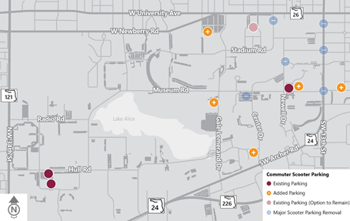

**Figure 5. Proposed Scooter Parking Lots** [6]

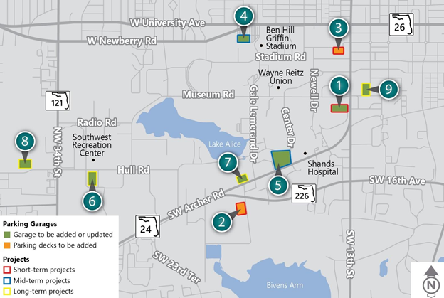

**Figure 6. Parking Spaces to be Added or Updated** [6]